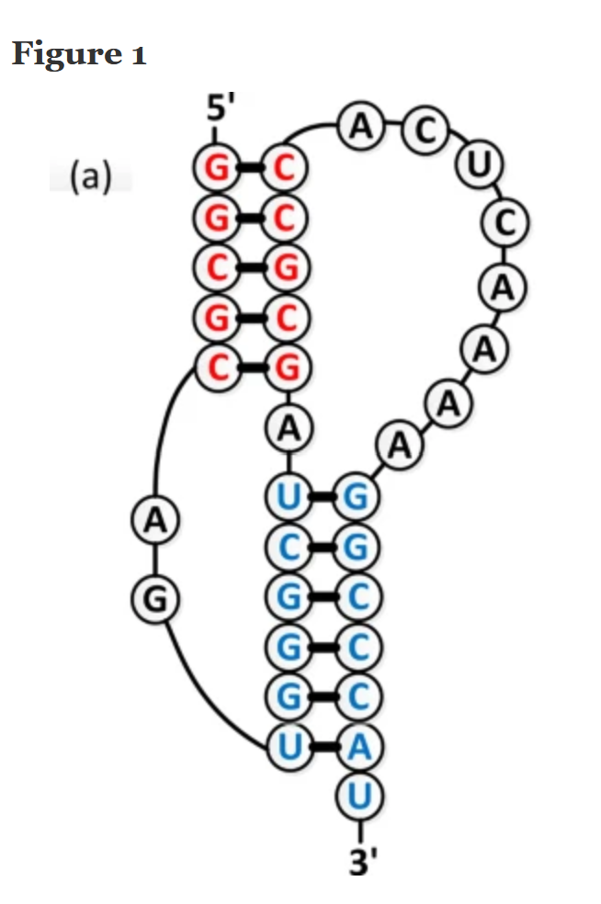1RNAK

Figure 2. Sequences and Structures of RNA Pseudoknots

Stems and loops are numbered sequentially, unless otherwise noted. Structure coordinates were obtained from the Protein Data Bank (<http://www.rcsb.org>), and structural representations were produced using MOLMOL software.

(A) HDV (1SJ3). Numbering of stems reflects standard nomenclature for HDV. The U1A RNA binding domain is colored gray and is not included in the three-dimensional structure.

(B) Diels-Alder ribozyme (DA-R) (1YLS).

(C) Human telomerase (hTR) (1YMO).

(D) MMTV (1RNK).

(E) Pea enation mosaic virus RNA1 (PEMV-1) (1KPZ).

(F) Simian retrovirus 1 (SRV-1) (1E95).

<https://doi.org/10.1371/journal.pbio.0030213.g002>

<https://doudnalab.org/Publications/nature-395-567.pdf>

**1DRZ**

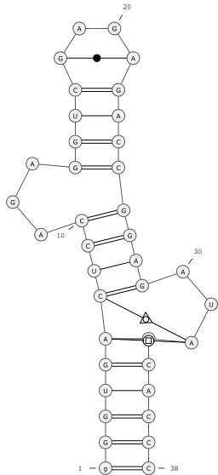from PDBee

Bulge

# N°accession pdb: 2A9L

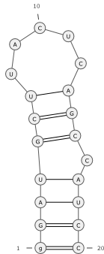 from PDBee

# N° accession: 7FHI

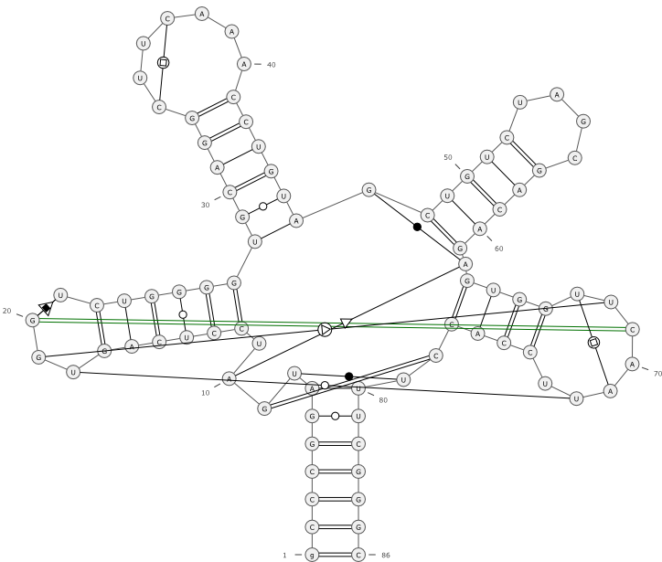 from PDBeee

# N°accession: 3A3A

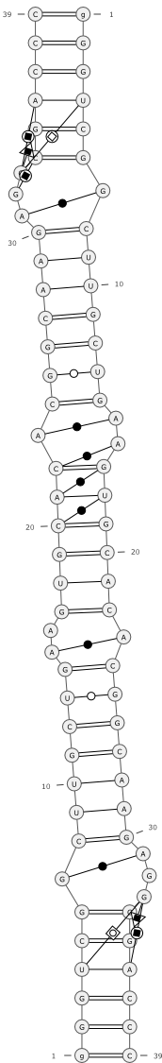N°accession: 2D1A

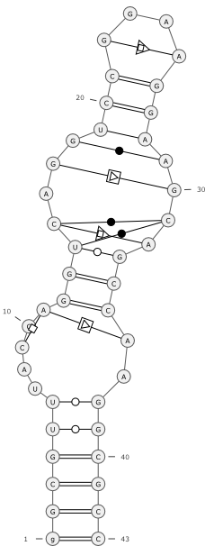

# 1CQL